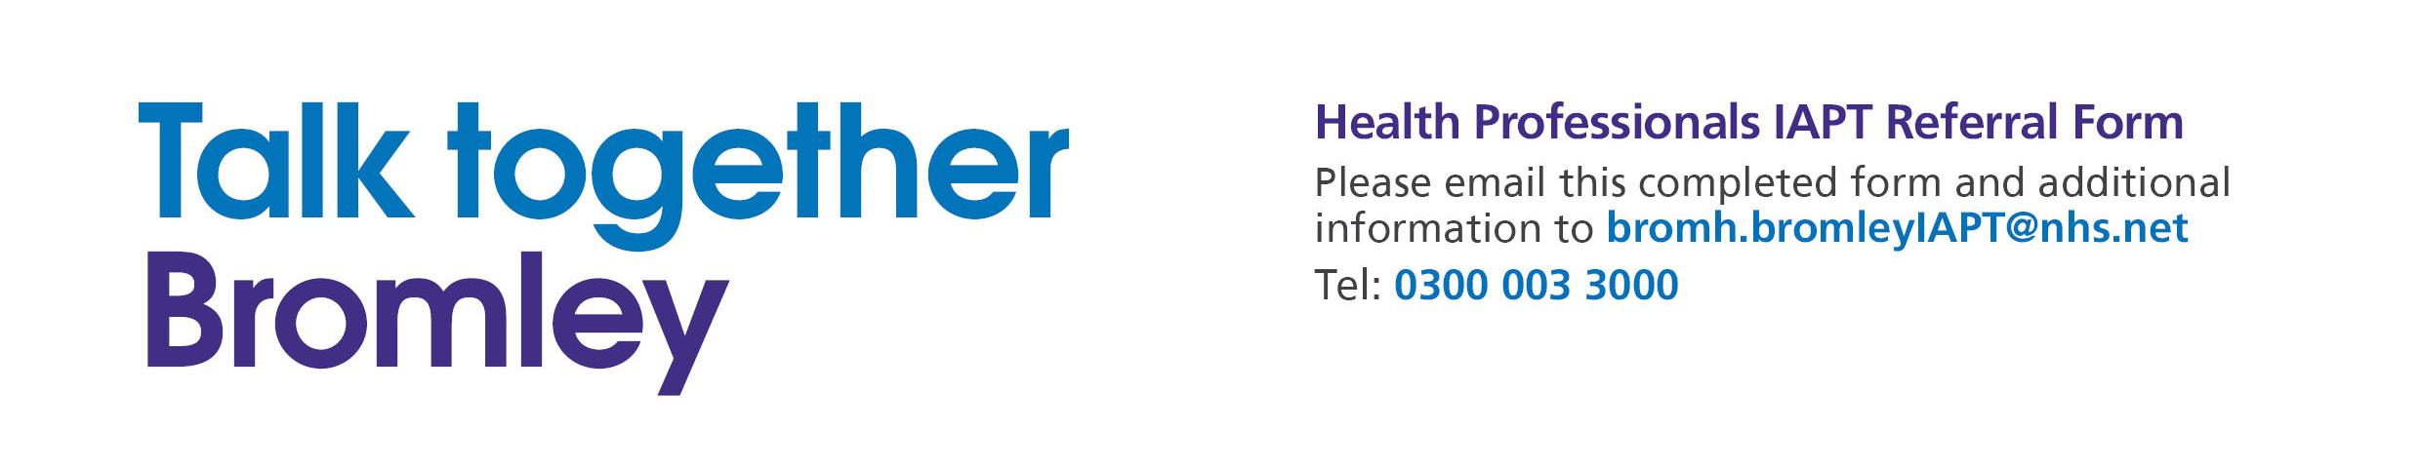

Patient’s Details
1.1 Patient name and address
Name: |  | DOB: | NHS No:
Address: |  | GP Name & Practice:
Postcode: |  | Date of referral:
Telephone number that the patient has consented to be contacted on:

1.2 Gender (please circle): Male / Female

1.3 Ethnicity: (please tick the appropriate box)

White British |  | Other mixed background |  | Indian
White Irish |  | Black African |  | Pakistani
Other White background |  | Black Caribbean |  | Bangladeshi
Mixed White & Black African |  | Other Black ethnic group |  | Prefer not to state
Mixed White & Asian |  | Black – Other mixed |  | Other (please state)

1.4 Please state if the patient has any special needs or requirements
(e.g., cannot use stairs, is housebound, communication difficulties, needs access to interpreter, etc.)

2. Patient’s Presenting Problem
2.1 Please highlight the patient’s presenting problem(s) by ticking one or more boxes below:

Depression
Generalised anxiety disorder
Obsessive compulsive disorder (OCD)
Post-traumatic stress disorder (PTSD)
Social phobia
Panic disorder (with or without agoraphobia)
Mixed anxiety & depression
Medically unexplained symptoms (please give details in next section)
Other (please state):

2.2 Please also give specific details regarding the nature of the presenting problem.

2.3 Please state the patient’s score on the following measures: (Please send copy of completed questionnaire with this form)

PHQ-9 (depression) score: GAD-7 (anxiety) score:
2.4 Have you or another GP seen the patient at least twice in the last 4 weeks? Yes / No

2.5 Has the patient got a long term physical health condition? (e.g., COPD, CHD, diabetes, chronic pain)
Yes / No

3. Patient’s Relevant History
3.1 Please give details of any current/past RISK issues (i.e., risk to self or others)

3.2 Is the patient currently involved with any other counselling, psychological therapy or mental health service? Or have they accessed mental health services in the past?
(If yes, please give details, dates and include discharge letter)

3.4 Please tell us about any other relevant information that may impact on any psychological therapy treatment that is important for us to know?
(e.g., medication which may affect mood or behaviour, social context, life events, etc.)

4. Treatment Options and Outcome

4.1 Please indicate which treatment you think may be appropriate, or the patient would prefer:

Guided self-help (e.g., workbook based CBT)
Groups based on CBT principles (e.g., Managing Depression/ Managing Anxiety/Managing Stress)
One to one high intensity CBT
One to one counselling
Other Psychological Therapy (state if known):
Job Retention Service
Other (please state)

Please note that a decision about the most suitable intervention will be made by the Working for Wellbeing assessment team. Most patients will receive guided self-help or a group intervention initially.

5. Referrer’s Details:

Name: |  | Team/Surgery |  | Telephone:

