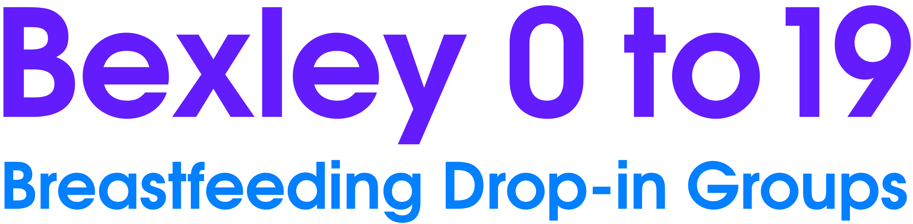
These friendly groups, where you can relax and meet other mothers, are run by NHS staff and breastfeeding specialists who know a lot about infant feeding and can help you:
- Get started with breastfeeding
- If you have questions or problems with breastfeeding
- When you are ready to stop breastfeeding
- When returning to work
- When introducing solids
The groups are not just for problems; you can relax and meet other local mothers to find out about family activities and support available at the Children’s Centres. For more information online please visit: bexley0to19.co.uk

Join us on Facebook: Bexley 0 to 19 Follow us on Twitter: @bexley0to19
Monday
Danson Children’s Centre  Brampton Rd, Bexleyheath, DA7 4EZ | 12:00-14:00 | 0208 303 6052
Wednesday
Sidcup Baby Cafe  North Cray Neighbourhood Centre  1 Davis Way, Sidcup, DA14 5JR  *Term time only*  Please note during school holidays the group will be held at Danson Children’s Centre, Brampton Road, Bexleyheath, DA7 4EZ. | 13:30-15:15 | 0208 308 3881  07738 117009
Thursday
Erith Baby Group  West Street Children’s centre  174 Chandlers Drive, Erith, DA8 1LW | 10:00-11:30 | 0203 045 5480
Local Volunteers
Helene Hamiliton | 0208 850 6864
Aishah Safdar | 07854 120443
Judianne Sherrel | 01322 224072
Free telephone and online baby feeding support and information
Voluntary Organisations
National Childbirth Trust (NCT) | 08:00-24:00 | 0300 330 0700
La Leche League (LLL) | 24 hours | 0345 120 2918
Breastfeeding Network (BfN) | 09:30-21:30 | 0300 100 0210
Association of Breastfeeding Mothers (ABM) | 09:30-21:30 | 0300 330 5453
National Breastfeeding Helpline | 09:30-21:30 | 0300 100 0212
Breast Pump Agents
Alison Davis | 0208 300 4970
Trish Molinari | 0208 300 2606

